**Module 4 - Fundamentals of AI**

**Course Number:** EAI 6000

**Academic Term:** Fall 2020 CPS Analytics  
**Instructor’s Name:** Kasun Samarasinghe

**Assignment Completion Date:** 11-20-2020

**Submitted By:**

Dhiren Vasudev Pagrani

Sunil Raj Thota

Shivani Sharma



**INTRODUCTION**

In this report, we will build a network model to predict the outcome of our Mechanism of Action (MOA) using Regression Analysis. Before applying regression analysis on our dataset lets understand the basics of regression analysis and its implications. We will also see how neural networks helps in building model seamless and help predict results with minimal errors,

Regression analysis can assist you with displaying the connection between a dependent variable (which you are attempting to anticipate) and one or more independent variables (the contribution of the model). Regression analysis can show if there is a huge connection between the autonomous factors and the needy variable, and the quality of the effect—when the free factors move, by the amount you can anticipate that the needy variable should move.

The simplest, linear regression equation looks like this:



Where

y - Dependent variable

X2, 3...k - Independent variables

(Beta) 1,2, 3...k - Coefficients

(Error) - Distance between value predicted by the model and the actual dependent variable y

Regression in Neural Networks

Neural organizations are reducible to regression models - a neural organization can "pretend" to be any sort of regression model. For instance, this exceptionally basic neural organization, with just one information neuron, one hidden neuron, and one output neuron, is identical to logistic regression. It takes several dependent factors = input boundaries, multiplies them by their coefficients = weights, and runs them through a sigmoid initiation work and a unit step function, which intently looks like the calculated relapse work with its mistake term.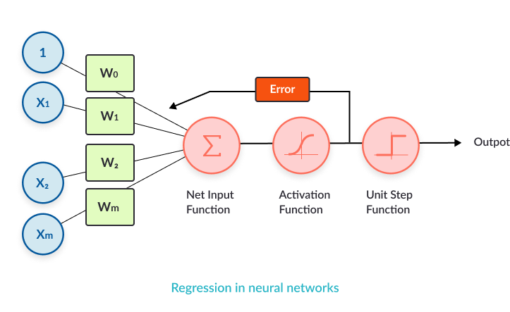

The logistic regression we modeled above is reasonable for binary classification. Imagine a scenario where we have to demonstrate multi-class grouping. We can build the intricacy of the model by utilizing various neurons in the hidden layer, to accomplish one-versus all order. Every order choice can be encoded utilizing three parallel digits.

Pros and Cons using Neural Networks as opposed to other ML models

|  |  |
| --- | --- |
| Pros | Cons |
| * Neural organizations are adaptable and can be utilized for both regression and classification issues. Any information which can be created numeric can be utilized in the model, as a neural organization is a numerical model with approximation capacities. | * Neural networks are black boxes, which means we can't realize how much every autonomous variable is impacting the dependent variables. |
| * Neural networks are acceptable to show with nonlinear information with an enormous number of contributions; for example, pictures. It is solid in a methodology of errands including numerous highlights. It works by parting the issue of characterization into a layered organization of easier components. | * It is computationally over the top expensive and tedious to prepare with customary CPUs. |
| * When prepared, the expectations are pretty quick. | * Neural networks rely a ton upon preparing information. This prompts the issue of over-fitting and speculation. The mode depends more on the preparation information and might be tuned to the information. |
| * Neural organizations can be prepared with quite a few sources of info and layers. |  |
| * Neural organizations work best with more information focuses. |  |

Reference:

1. Missinglink.ai, (n.d), Neural Networks for Regression (Part 1)—Overkill or Opportunity? Retrieved from

<https://missinglink.ai/guides/neural-network-concepts/neural-networks-regression-part-1-overkill-opportunity/#:~:text=Regression%20in%20Neural%20Networks,equivalent%20to%20a%20logistic%20regression>.

1. Packt, (n.d), Pros and cons of neural networks, Retrieved from

https://subscription.packtpub.com/book/big_data_and_business_intelligence/9781788397872/1/ch01lvl1sec27/pros-and-cons-of-neural-networks